**Project Report**

**Background and Motivation**

Urban parking spaces are scarce and demand fluctuates rapidly based on time of day, special events, and traffic conditions. Static pricing leads to either overcrowding or under-utilization. Dynamic pricing can help optimize usage and revenues for parking operators.

This project implements a dynamic pricing engine using real-time data streams and machine learning models.

**Models Implemented**

**Model 1 – Baseline Linear Model**

We use a simple linear function:

* Base price starts at $10.
* The price increases proportionally with occupancy.
* Prices are clipped between $5 and $20 to avoid extremes.

**Model 2 – Demand-Based Model**

We compute a demand score:



* Parameters:
  + α = 2.0
  + β = 0.8
  + γ = 1.0
  + δ = 2.0
* Vehicle type weights:
  + Car → 1.0
  + Bike → 0.5
  + Truck → 1.5

The price is computed as:



* λ = 0.5
* Price is bounded to avoid excessive swings.

**Model 3 – Competitive Pricing Model**

We compute distances between parking lots using the Haversine formula. If nearby lots are cheaper, the price reduces slightly. If nearby lots are expensive, the price may increase.

The adjustment formula:

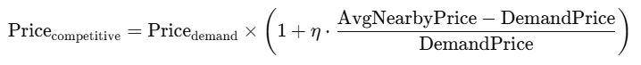

* η = 0.1
* Ensures smooth, minor adjustments only.

**Assumptions**

* Traffic levels are mapped:
  + low → 1
  + medium → 2
  + high → 3
* Prices cannot go below $5 or exceed $20.
* All models are computed in real-time.

**Visualizations**

**1. Baseline Pricing Visualization**

The **Baseline Price Table** shows how the price changes over time, depending only on occupancy levels. As occupancy increases, the price increases gradually, following a linear relationship.

**2. Demand-Based Pricing Visualization**

The **Demand-Based Price Table** adds more intelligence. Besides occupancy, it considers:

* Queue length
* Traffic conditions
* Special events
* Vehicle type

This model produces prices that fluctuate in response to these real-time features while keeping the variations smooth and bounded.

**3. Competitive Pricing Visualization**

The **Competitive Price Table** further refines pricing decisions by comparing prices across nearby parking lots:

* If nearby lots are cheaper, our price might decrease.
* If nearby lots are expensive, our price might increase to optimize revenue while staying competitive.

This ensures our system remains **responsive to real-world competition.**

**4. Average Occupancy Across Lots**

Finally, the **Average Occupancy Bar Chart** shows how many vehicles, on average, are parked in each lot over the entire dataset. This visualization helps identify:

* Lots with consistently high demand
* Underutilized lots with potential for price incentives

For example, some lots such as Others-CCCP513a exhibit extremely high average occupancy, indicating consistently high demand.

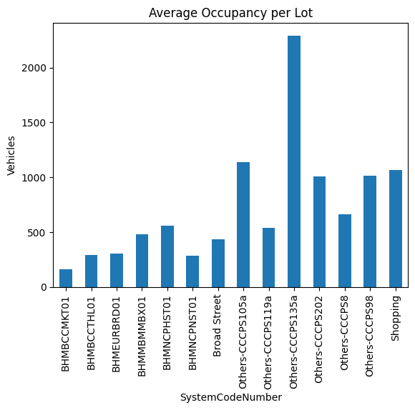

**Conclusion**

This dynamic pricing system successfully responds to real-time conditions, optimizes revenue, and improves parking space utilization in urban areas. The integration with Pathway allows efficient real-time price computation for scalable deployments.

**End of Report**